# Visitors can perform the follow actions:

### Allows to add a user

End Point: **POST** <http://localhost:7777/user>

Request:

{

"userId": 1,

"firstName": "Rama Krishna",

"lastName": "Raju K",

"email": "[rama@GMAIL.COM](mailto:rama@GMAIL.COM)",

"mobile": "512-968-9999"

}

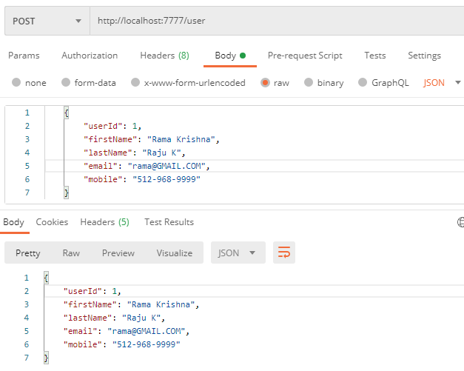

### Allows to delete an existing user

Endpoint: **DELETE** <http://localhost:7777/user/1>

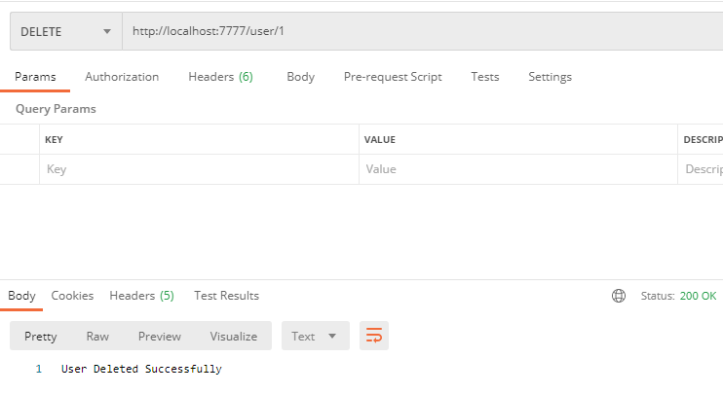

### Allows to display all the users

Endpoint: **GET** <http://localhost:7777/user>

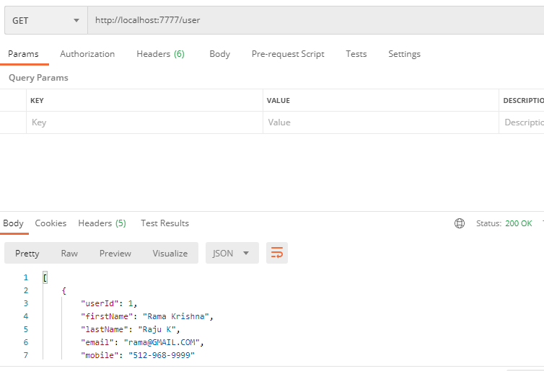

### Allow to add interview

Endpoint: **POST** <http://localhost:7777/interview>

{

"interviewId": 1,

"interviewerName": "Jaaram",

"interviewName": "SDET Role",

"usersSkills": "Spring,JPA, Selenium,Jav",

"time": "10:30",

"date": "2020-11-11",

"interviewStatus": "Scheduled",

"remarks": "Priority"

}

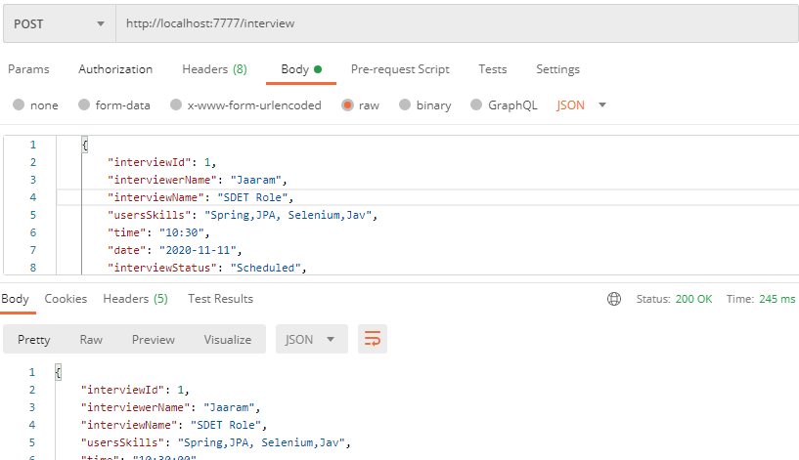

### Allow to delete an existing interview

Endpoint: **DELETE** <http://localhost:7777/interview/1>

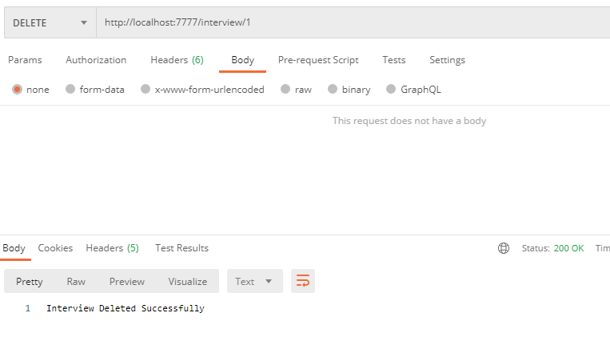

### Allow to update interview status on go

Endpoint: **PUT** http://localhost:7777/interview/updateStatus/1/In Progress

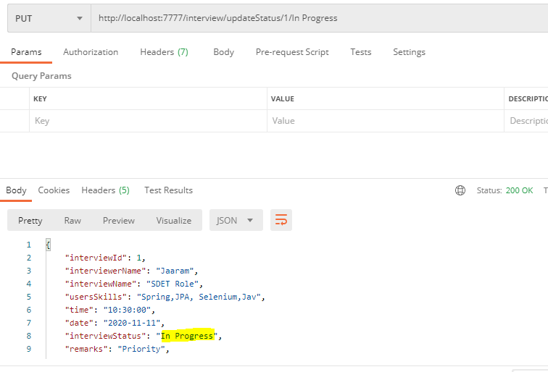

### Allows to search the interview on the basis of Interview Name and Interviewer Name

Endpoint: **GET** http://localhost:7777/interview/showInterviews/SDET Role/Jaaram

Note: I have used Or condition here not And in the select query, so you will receive results based on any one of the fields

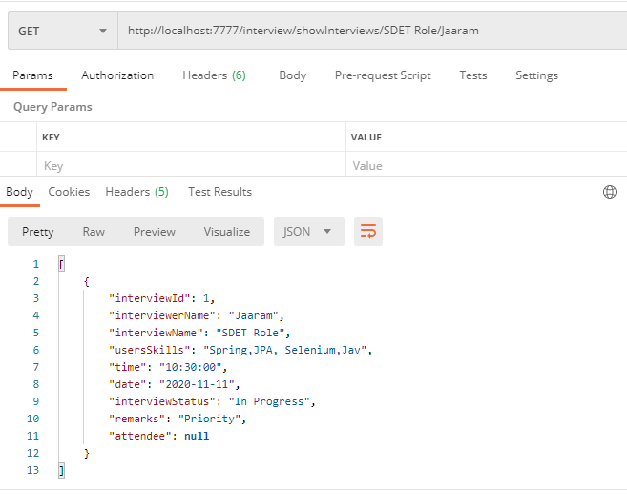

### Allows searching total no of count of interview.

End point: **GET** <http://localhost:7777/interview/count>

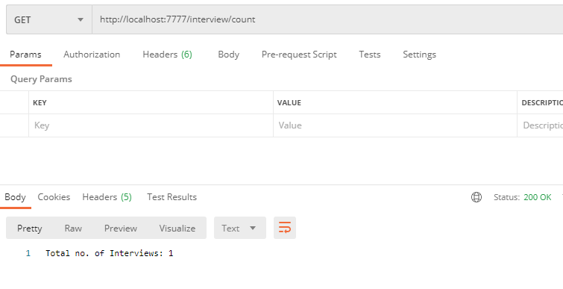

### Allows to display all the interviews

Endpoint: **GET** <http://localhost:7777/interview/showInterviews>

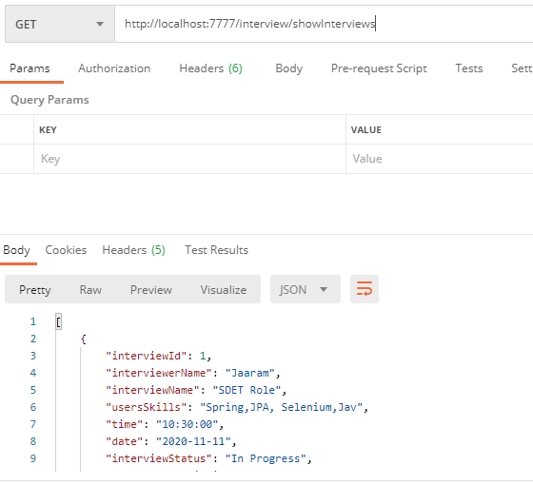

### Allow to add attendee to an interview

This can be achieved in 2 ways:

1. Add existing user as attendee to existing interview

End Point: **PUT** <http://localhost:7777/interview/addAttendee>

{

"interviewId": 1,

"userId": 3

}

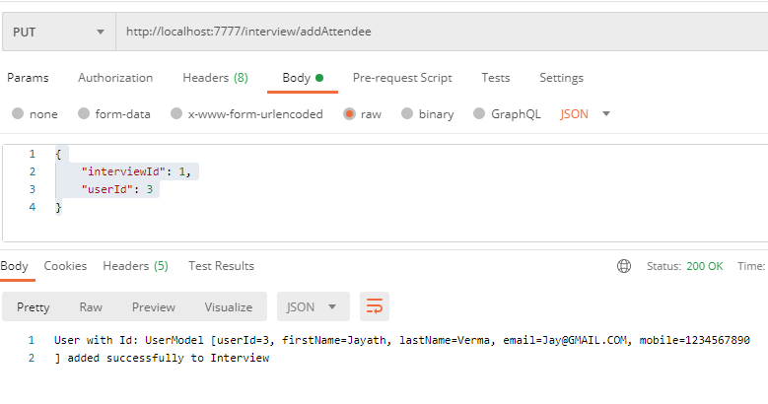

1. Add user as attendee to new interview

Endpoint: **POST** <http://localhost:7777/interview>

{

"interviewId": 1,

"interviewerName": "Jaaram",

"interviewName": "SDET Role",

"usersSkills": "Spring,JPA, Selenium,Jav",

"time": "10:30",

"date": "2020-11-11",

"interviewStatus": "Scheduled",

"remarks": "Priority",

"attendee": [

{

"userId":4,

"firstName": "Sarah",

"lastName": "Taylor",

"email": "[Sarah@GMAIL.COM](mailto:Sarah@GMAIL.COM)",

"mobile": "125-235-2583"

}

]

}

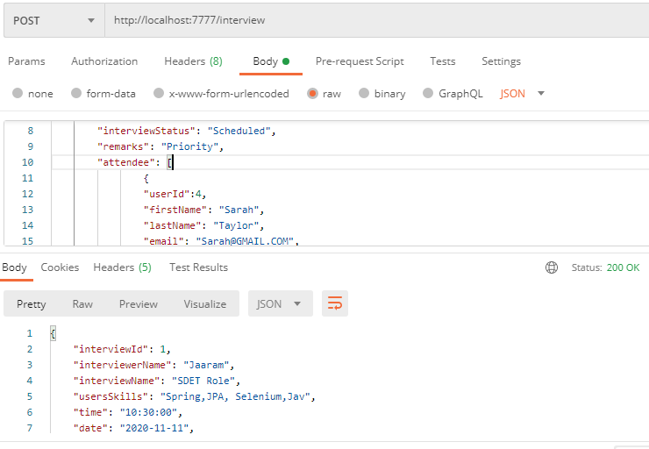

### Allow to show all attendee of an interview

Endpoint: GET <http://localhost:7777/interview/showAttendee/2>

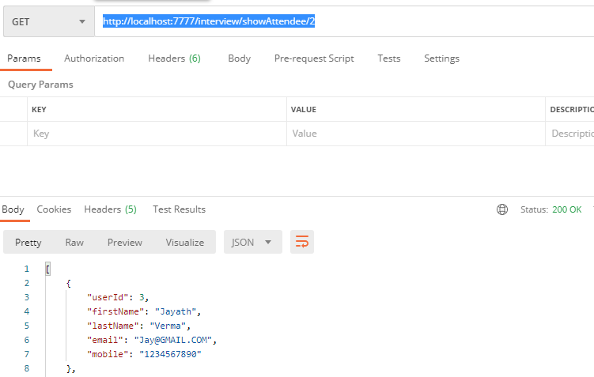

# Assumptions, Dependencies, Risks / Constraints:

### While adding a user to interview as attendee, if user id already exists, it should throw a custom exception.

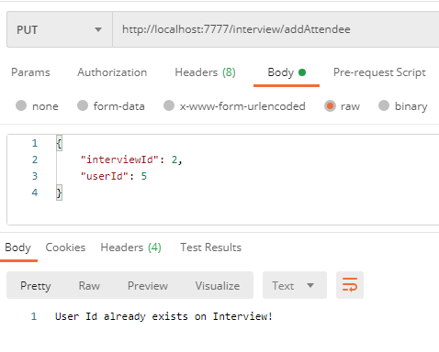

### While deleting the user and interview also, assumed that id already exists, else throw an custom exception

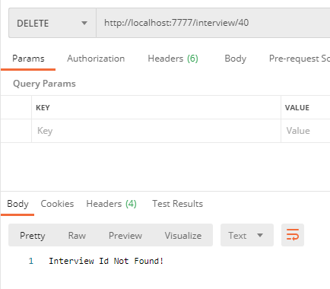

# MySQL Schema

mysql> drop database itsdb;

Query OK, 3 rows affected (0.72 sec)

mysql> create database itsdb;

Query OK, 1 row affected (0.09 sec)

mysql> use itsdb;

Database changed

mysql> show tables;

+--------------------+

| Tables_in_itsdb |

+--------------------+

| interview_schedule |

| interviews |

| users |

+--------------------+

3 rows in set (0.05 sec)

mysql> desc interviews;

+------------------+--------------+------+-----+---------+-------+

| Field | Type | Null | Key | Default | Extra |

+------------------+--------------+------+-----+---------+-------+

| i_id | int(11) | NO | PRI | NULL | |

| date | date | YES | | NULL | |

| interview_name | varchar(255) | YES | | NULL | |

| status | varchar(255) | YES | | NULL | |

| interviewer_name | varchar(255) | YES | | NULL | |

| remarks | varchar(255) | YES | | NULL | |

| time | time | YES | | NULL | |

| users_skills | varchar(255) | YES | | NULL | |

+------------------+--------------+------+-----+---------+-------+

8 rows in set (0.02 sec)

mysql> desc users;

+--------+--------------+------+-----+---------+-------+

| Field | Type | Null | Key | Default | Extra |

+--------+--------------+------+-----+---------+-------+

| u_id | int(11) | NO | PRI | NULL | |

| email | varchar(255) | YES | | NULL | |

| fname | varchar(255) | YES | | NULL | |

| lname | varchar(255) | YES | | NULL | |

| mobile | varchar(255) | YES | | NULL | |

+--------+--------------+------+-----+---------+-------+

5 rows in set (0.00 sec)

mysql> desc interview_schedule;

+--------------+---------+------+-----+---------+-------+

| Field | Type | Null | Key | Default | Extra |

+--------------+---------+------+-----+---------+-------+

| interview_id | int(11) | NO | MUL | NULL | |

| user_id | int(11) | NO | MUL | NULL | |

+--------------+---------+------+-----+---------+-------+

2 rows in set (0.00 sec)